Strategic Alignment Task Force

Business Case Submission

PROJECT TITLE



|  |  |  |  |  |
| --- | --- | --- | --- | --- |
| **SATF Key Funding Pillars**  **Tick the appropriate pillar** | | | | |
| **Care in Hospital Setting** | **Research** | **Education** | **Innovation** | **Major Initiative** |
|  |  |  |  |  |

|  |  |
| --- | --- |
| Prepared By: |  |
| Email Address: |  |
| Phone Number: |  |
| Department/Office: |  |
| Children’s Health Ireland Site: |  |
| Date Submitted: |  |
| Amount Requested:  Vat Amount:  Total Amount: | €  €  € |
| SATF REF: (issued by Children’s Health Foundation) |  |

**STRATEGIC ALIGNMENT TASK FORCE – SUBMISSION GUIDELINES**

The Strategic Alignment Task Force (SATF) will only consider projects over **€500,000** that meet one of the core pillars for funding:

* Care in Hospital Setting
* Research
* Education
* Innovation
* Major Initiative

All requests will be assessed and scored against a set list of key criteria. These criteria will consider donor and Children’s Health Ireland funding priorities.

**This application form should be completed, and all supporting documentation attached to clearly articulate the identified need and how this project sets out to address that need.**

All sections of the application form must be completed for SATF consideration. Each section must be filled out clearly and concisely, with consideration given to the SATF members of a non-medical background.

On completion, the application forms should be emailed in PDF format only to the Chief Executive Officer of Children’s Health Ireland, [ceo@nchg.ie](mailto:ceo@nchg.ie) for review and sign off. Once signed off please submit on the Children’s Health Foundation website.

Applicants should **not** send applications directly to the Foundation, these must be reviewed by the CEO of Children’s Health Ireland as per the guidelines set out.

**Funding Criteria**

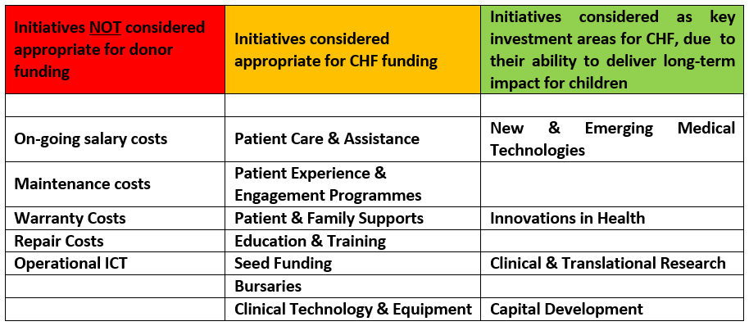

***Please Note:*** *By submitting this proposal you confirm that all information included in this application is correct and can be used by the Foundation for information purposes.*

|  |
| --- |
| **REQUEST TITLE** |
|  |

|  |  |  |  |
| --- | --- | --- | --- |
| **PROJECT TIMELINE & KEY MILESTONES SUMMARY**  *Please attach a details timeline as per the sample provided as Appendix 1* | | | |
| Start Date |  | End Date |  |

|  |  |
| --- | --- |
| **EXECUTIVE SUMMARY**  Please include a high-level summary of the project, the aims and objectives of the project and the impact this project will have for Ireland’s sickest children. | |
|  | |
| **BACKGROUND & CONTEXT**  *Set the scene by providing background information on the issue you are trying to combat. This should provide the rationale for the project and how it affects paediatric health on a national scale.* | |
|  | |
| **CURRENT SERVICE PROVISION**  *Please explain the ‘As Is’ – what is currently being done to tackle this issue, the structures currently in-place and what is working or not working.* | |
|  | |
| **THE PROPOSAL**  *Please describe the project for which you are seeking funding, and how it works? In this response, please outline how this proposal strategically addresses the issues previously outlined and how it will benefit Ireland’s sickest children? In your response, please include the overall objectives of the project and the governance/operating structure of the project, where relevant* | |
|  | |
| **UNIQUE VALUE PROPOSITION**  *In this proposal, please describe what makes your project/service unique or different that could influence practice?* | |
|  | |
| **DRIVERS FOR NEW SERVICE/PROJECT**  *Please outline how this service/project will directly impact:*   * *Outcomes of Sick Children* * *Direct/Indirect benefits for parents, staff etc.* * *Healthcare Delivery and Provision* * *National Objectives for Paediatric Health* * *Children’s Health Ireland* | |
|  | |
| **DELIVERABLE OUTCOMES/ACTIVITY TO DATE**  *Include here the expected outcomes of the project, the estimated number of patients you proposes service/project is likely to impact on an annual basis, giving an indication of the minimum and maximum numbers. Please provide information on how you plan to monitor the impact of this project for the lifetime of the grant award and list KPIS, where relevant.*  *Please mention if this service/project will lead to greater efficiencies or freed up resources and over what timescale?* | |
|  | |
| **PATIENT & PARENT FEEDBACK**  *Please include any case studies, patient or parent quotes which would compliment your proposal that would strengthen your business case and bring it to life* |
|  | |
| **CHAMPION**  *Is there a Health Professional who will champion this project and explain the clinical benefits of this project to donors and other interested audiences? Please answer Yes/No and list name, where relevant* | |
|  | |

|  |
| --- |
| **OUR SUPPORTERS**  *Please explain why would a donor would want to fund and support this project? In your answer, please explain why this project/ service is a good use of donor funds and offers value for money.* |
|  |

|  |
| --- |
| **PROJECT BUDGET SUMMARY**  **Please provide a detailed budget in Appendix 2** |

|  |  |  |  |  |
| --- | --- | --- | --- | --- |
| **Category** | **Year 1** | **Year 2** | **Year 3** | **Total** |
| Staff Costs |  |  |  |  |
| Equipment Costs |  |  |  |  |
| Consumables / Materials |  |  |  |  |
| Other Costs |  |  |  |  |
| **Total** |  |  |  |  |

|  |
| --- |
| **Impact on Hospital Departments** |

*Children’s Health Foundation do NOT fund the costs of software and maintenance on an on-going basis. Therefore, it is strongly recommended that you consult the relevant Department Head.

|  |
| --- |
| *Please confirm that you have consulted the relevant Department Head and fill in the appropriate box below if your project will have an impact on resources for any Children’s Health Ireland*  *department eg. Staffing/man hours, machine hours, extra costs or items such as service/maintenance contracts etc. This must be signed by the relevant Department Head eg. ICT, HR, Clinical Engineering, Projects Office.* |

|  |  |  |
| --- | --- | --- |
| **Department** | **Provide details & likely associated costs.** | **Department Head Signature** |
| Finance |  |  |
| ICT |  |  |
| Human Resources |  |  |
| Project Office |  |  |
| Clinical Engineering |  |  |
| MDC – Medical Device Committee |  |  |
| Laboratory |  |  |
| Pharmacy |  |  |
| Research & Innovation Office (RIO) |  |  |
|  |  |  |

|  |  |  |
| --- | --- | --- |
| **APPENDICES**  ***Please check you have included the essential documentation required in support of this application*** | | |
| **Appendix** | **Document Type Example** | **Received by Children’s Health Foundation** |
| Appendix 1 | Project Timeline |  |
| Appendix 2 | Details Budget & Quotes |  |
| Appendix 3 | Supporting Documentation as required |  |
| Appendix 4 |  |  |

|  |  |  |
| --- | --- | --- |
| **\*RESEARCH PROJECT APPENDICES**  ***Please check you have included the essential documentation required in support of this application*** | | |
| **Appendix** | **Document Type** | **Received by Children’s Health Foundation** |
| Appendix 1 | Ethics Committee Approval Letter |  |
| Appendix 2 | Research Committee Approval Letter |  |
| Appendix 3 | Head of Research and CHI CEO Letter of Support |  |

*All projects funded by the Foundation must provide an EOP (end of project) report no later than 3 months after completion.

CHI AUTHORISATION

|  |  |
| --- | --- |
| **Proposer** | |
| Name |  |
| Signature |  |
| Date |  |
| **Department Head** | |
| Name |  |
| Signature |  |
| Date |  |

|  |  |
| --- | --- |
| **Children’s Health Foundation Use Only – Children’s Health Foundation** | |
| Children’s Health Foundation  Decision: |  |
| Conditions Applied: |  |
| Signature: |  |
| Date Approved: |  |